Bluejay KyroTouch
Empowering India’s Digital Learning Ecosystem
Interactive Flat Panels (65” & 75”)
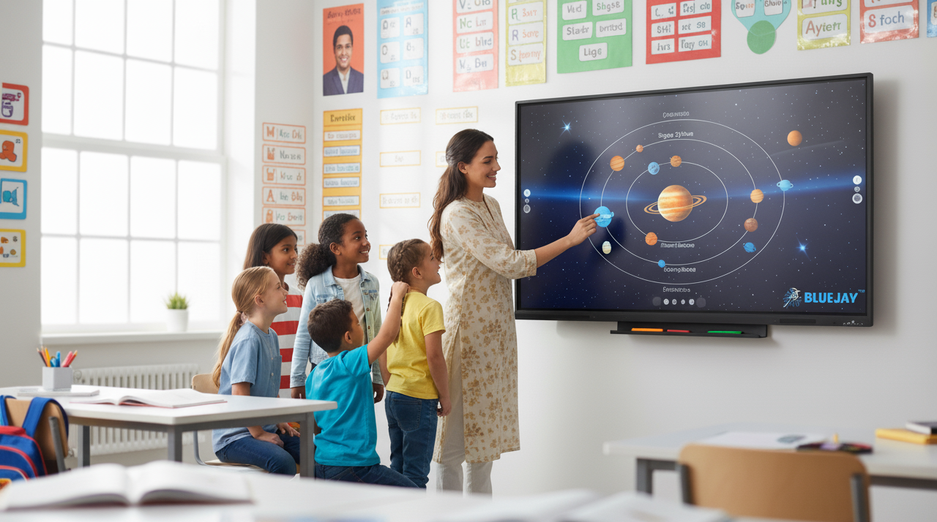

Bluejay Innovative Labs Pvt Ltd
1st Floor, Dwaraka Park View, Plot No 14/2, Sector-1,
HUDA Techno Enclave, Madhapur, Hyderabad, Telangana 500081
Ph: +91 80194 44755
Email: info@bluejayinnolabs.com

Our Mission & Vision
Mission
Bluejay is committed to empowering India’s digital education mission with cutting-edge technology. Our KyroTouch panels are designed in line with government education initiatives like Smart Classrooms, Digital India.
Vision
To enable equitable, tech-driven education for every student in India.
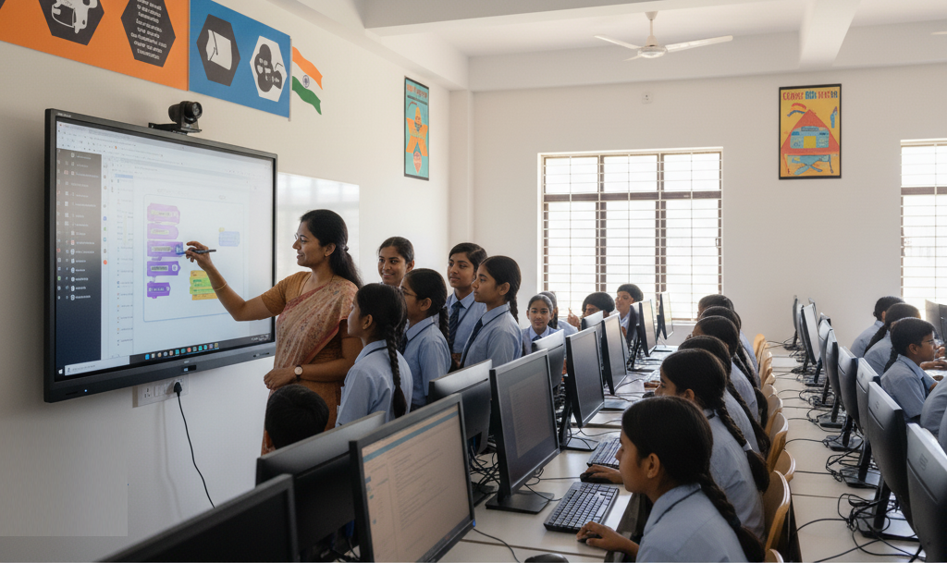

About Bluejay
Bluejay Innovative Labs is a Hyderabad-based technology brand focused on creating reliable and accessible hardware solutions. We specialize in conference systems, AV products, and home-office equipment designed to make work smarter and more efficient. Backed by strong service support and a commitment to quality, Bluejay aims to deliver products that combine performance, practicality, and value, helping professionals and businesses get the most out of their everyday technology.
Why Bluejay KyroTouch?
The BLUEJAY KyroTouch is a high-performance interactive flat panel tailored for smart classrooms, boardrooms, and collaborative workspaces. With crystal-clear 4K resolution, ultra-responsive 40-point infrared touch, and Android 14.0 onboard, KyroTouch makes every session more intuitive, interactive, and productive.

- Immersive 4K UHD visuals for impactful teaching and presentations.
- Ultra-responsive 40-point multi-touch for smooth and natural interaction.

- Dual OS compatibility – Android 14 and OPS (Windows/Linux).
- Powerful dual 16W speakers ensure clear audio for classrooms.
- Easy connectivity: HDMI, USB-C, USB 3.0, RS232, RJ45, Wi-Fi 6, Bluetooth 5.2.
- Durable 3.2mm anti-glare tempered glass for long-term use.
- Energy-efficient, optimized for schools and government projects.
- Certified safe and sustainable (BIS, CE, FCC, RoHS).

Specifications
Feature | Details
Sizes Available | 65” & 75”
Resolution | 4K UHD (3840 × 2160)
Brightness | 350 nits (typical), 300 nits (min)
Contrast Ratio | 5500:1
Touch Technology | 40-point IR multi-touch, ±1.5mm accuracy
Glass | 3.2mm tempered, anti-glare
Operating System | Android 14.0; OPS slot supports Windows/Linux
RAM & Storage | 4GB+32GB (standard), 8GB+128GB (optional)
Audio | 2 × 16W speakers, 84dB output
Connectivity | HDMI ×3, USB 3.0 ×3, USB-C, Audio In/Out, RS232, RJ45
Wireless | Wi-Fi 6 (2.4/5GHz), Bluetooth 5.2
Certifications | BIS, CE, FCC, RoHS





Where Bluejay KyroTouch Makes a Difference

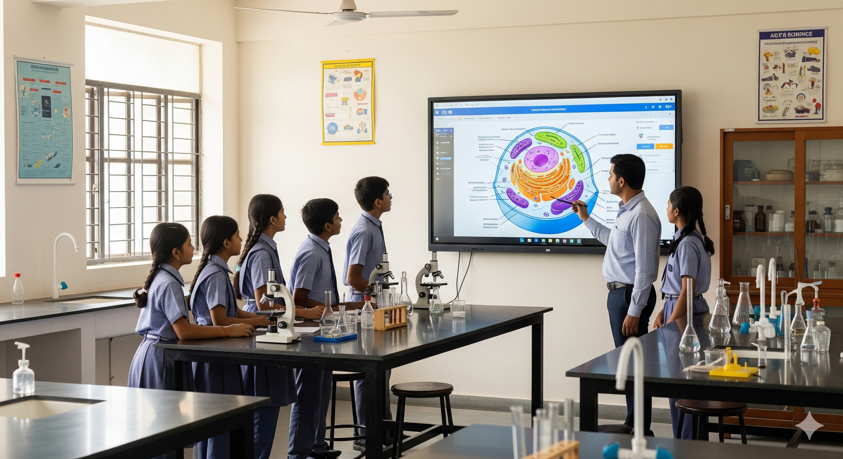
- Government Schools & Smart Classrooms – Engaging, interactive learning experiences.
- Digital Labs & Robotics Centers – Ideal for coding, experiments, and STEM education.
- Teacher Training Institutes – Enhances digital pedagogy and capacity building.
- Government ICT & Education Projects – Certified for compliance and large-scale rollouts.

- Libraries & Digital Knowledge Hubs – Interactive knowledge sharing and research.
- Corporate Training & Skill Development – Professional upskilling and learning programs.
- Meeting Rooms & Auditoriums – Presentations, seminars, and video conferencing.
- CSR & Public Sector Programs – Scalable solution for nationwide education outreach.

Transform Learning Today
Upgrade your classrooms with Bluejay KyroTouch – a trusted, certified solution for India’s digital future.

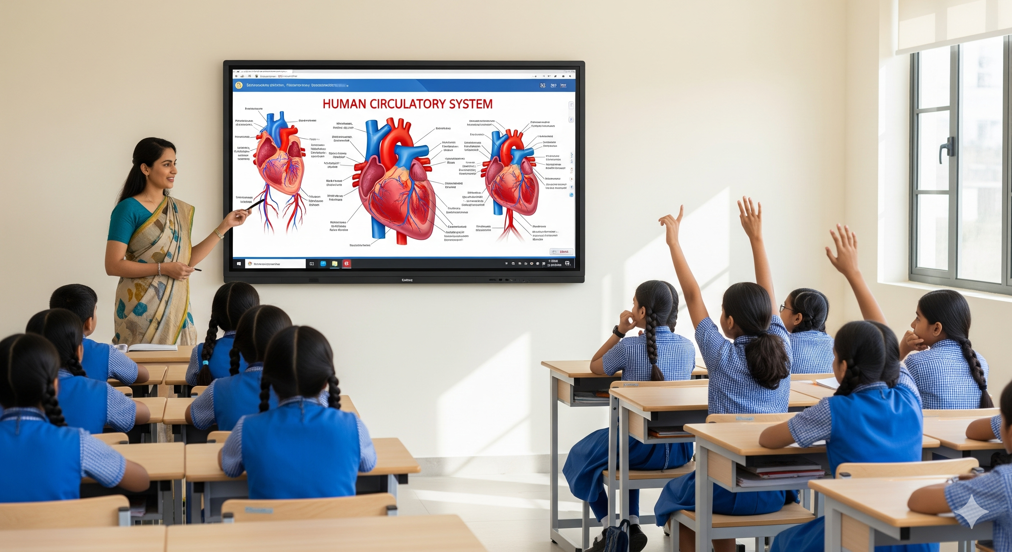

Contact us today to bring interactive learning to your classrooms.

Bluejay Innovative Labs Pvt Ltd
https://www.bluejayinnolabs.com/

